Using MS SQL Server to create a Workshop1 Database

1. **Create Student Table as following**

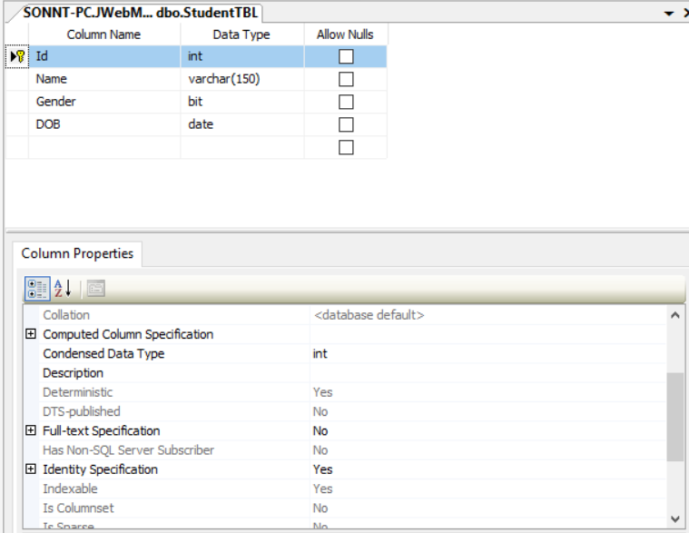

* The id is added identity (1,1) constraint\

1. **When user typing:**

* [Server name]:[port]/[Your Application]/student/list ,display all students as below screen:

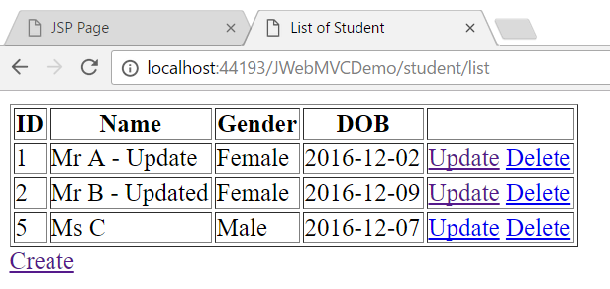

1. **When user clicks Create hyperlink**
   * redirect user to student/create where his/her can add a new student. After adding new student , system automatically came back the student/list

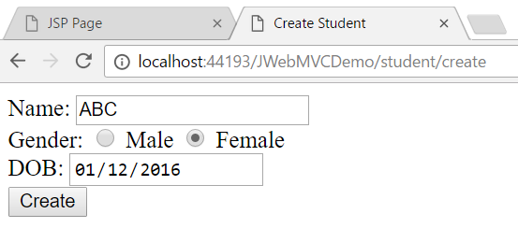

1. **When user clicks Update hyperlink (student/list)**
   * Redirect user to student/update where his/her can update the info of student corresponding to the selected row. After updating student , system automatically came back the student/list

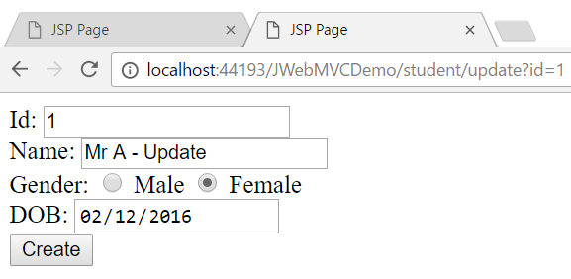

1. **When user clicks Delete hyperlink (student/list)**
   * remove the corresponding student in the database and show the effective to the user.